ST10341842

MVINJELWA  BUHLEBENKOSI

DATA6222 tEST 1

**Question 1**

**Q.1.1**

* **Screenshots CREATE TUTOR, SCHOOL AND SESSIONS code**

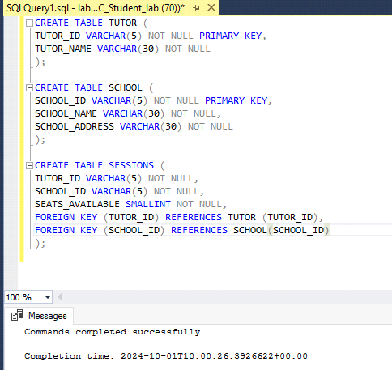

* **Table 1 TUTOR**

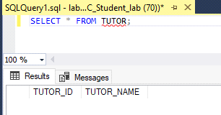

* **Table 2 SCHOOL**

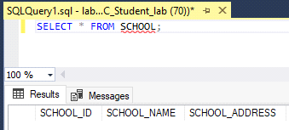

* **Table 3 SESSIONS**

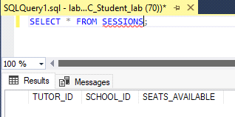

**Q1.2**

* **Screenshot INSERT INTO TUTOR code**

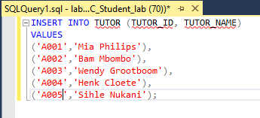

* **Table 1 TUTOR**

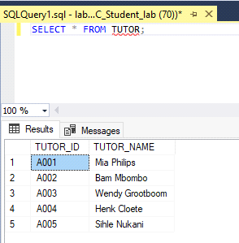

* **Screenshot INSERT INTO SCHOOL code**

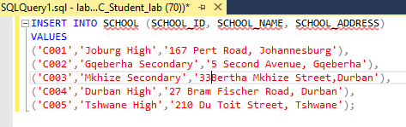

* **Table 2 SCHOOL**

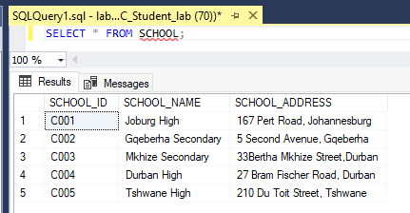

* **Screenshot INSERT INTO SESSIONS code**

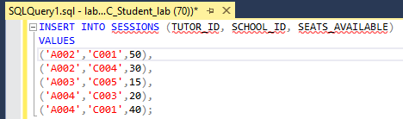

* **Table 3 SESSIONS TABLE**

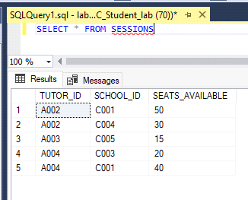

Q.1.3

* **Screenshot Alter SESSIONS Code**

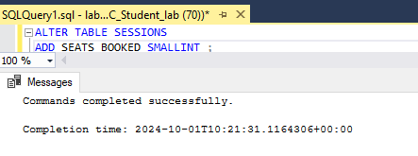

* **Screenshot Altered SESSIONS Table**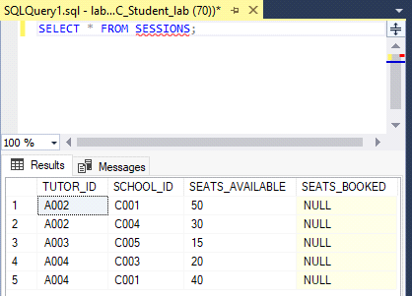

Q.1.4

* **Screenshot Update SESSIONS Code**

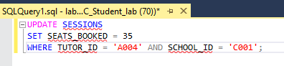

* **Screenshot Updated SESSIONS Table**

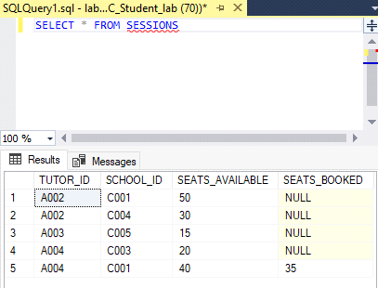

**Question 2**

Q.2.1

**Screenshot Output and Code**

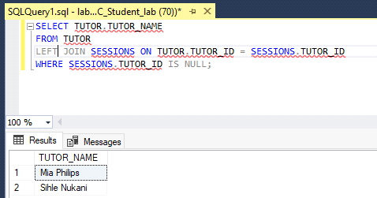

Q.2.2

**Screenshot Output and Code**

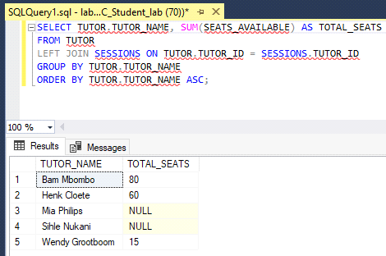

Q.2.3

**Screenshot output and code**

